CS1050 Technical Documentation
Use headings to organize topics and create a table of contents to be able to quickly access information.

After adding new headings to organize your documentation, refresh the table of contents below.
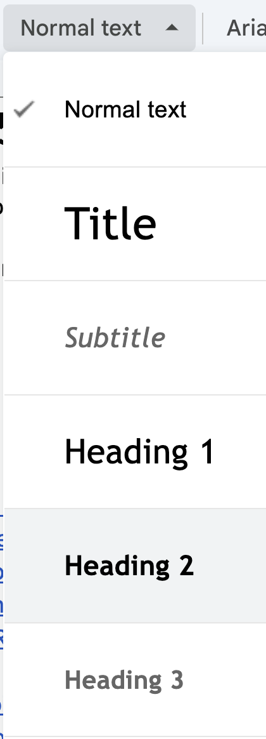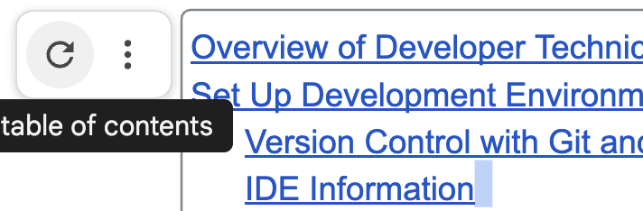

Overview of Developer Technical Documentation
Set Up Development Environment
General Resources
Module 01: Fundamental Programming Concepts
Compilation and Errors
Primitive Data Types, Variables, Constants, and Naming Conventions
Arithmetic Operators and Combined Assignment Operators
Memory Allocation, Conversion and Casting
Code Sample
ANY OTHER TOPIC?
Module 2
Module 3
Module 4
Module 5

Follow the 4 tips from Part 2: Developer Technical Documentation:
Importance of Being Concise:
- Developers need clear and precise answers.
- Use short sentences, small paragraphs, and simple language.
- Avoid unnecessary complexity to improve clarity.
Avoiding Technical Jargon:
- Simplify writing to ensure accessibility.
- Use standard industry terms if technical language is necessary.
Using Code Snippets:
- Show what the product can do with practical examples.
- Elevates documentation quality by catering to developer familiarity with code.
Role of Visuals:
- Screenshots, GIFs, and videos enhance engagement and understanding.
- Visuals simplify complex processes and reduce lengthy explanations.

Overview of Developer Technical Documentation
I use headings to help organize and easily access information. I like to include snippets of code that contains comments as an easier way to have documentation. You can put in the document what is helpful for you.

Use information from class lectures, guided exploration, code examples from class and book to be able to use later to help you and approach it as if you could help someone else.

GE 01 Put technical documentation below to demonstrate your understanding of Module 1:
- Understand and set up the programming environment (Eclipse, Git, and GitHub).
- Apply version control using Git and document changes effectively.
- Write basic Java programs using variables, constants, and logical structures.
- Debug code using Eclipse IDE and reflect on common syntax and logical errors.
- Develop concise and structured technical documentation.

Set Up Development Environment
Provide the following but you can copy and paste my steps and add any additional or update my information for you. Make your documentation your own but follow best practices. Create headings that make sense to you.
- Overview of tools
  - Eclipse IDE for Java development
  - Git and GitHub for version control
- Git and Github
  - Overview of tools
  - Steps to set up
  - Steps to use desktop ( or command line if you know it) to version locally and back up on server
- Set Up IDE (Eclipse):
  - Overview of you IDE
  - Steps to install
  - Configure the workspace to store projects.
  - Verify JDK installation.
  - Creating future projects and class files
  - Use IDE for debugging -

General Resources
Here you can list resources that you use frequently and keep adding to them over the course of the class (lectures, book, tutorials, etc)
- Shared student CS1050 resources
- [ADD OTHER RESOURCES]

Module 01: Fundamental Programming Concepts

Add information for each subheading below. I have some information to get started

Compilation and Errors

For examples here are some code resources on errors
- SyntaxErrors
- RuntimeErrors
- LogicErrors

Syntax Errors

- Occurs when the programmer either misspelled, correct capitalizations or not, missing a letter or punctuations and special characters. Above all, incorrect grammar.

Runtime Errors

- Runtime error occur while the program is running and not before executing the code.

Logic Errors

- Logic errors are when a program gives unexpected or wrong results than what you’re looking for, but the syntax is correct.
____________________________________________________________________________

Primitive Data Types, Variables, Constants, and Naming Conventions

This website describes primitive data types Java Data Types - javatpoint

- boolean data type
- Single bit of information that can take two possible states
- True or false
- 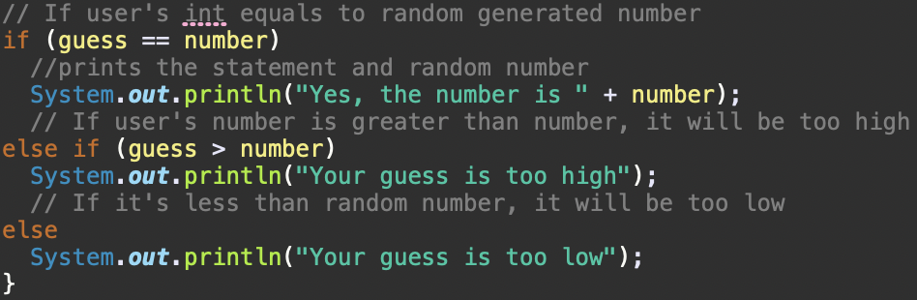

- byte data type
- 8-bit signed two’s complement integers
- Range of values from -128 to 127
- Default value 0
- Example: byte a = -58 byte b = 11
- char data type
- Single character
- Represent character, such as letters, digits, and symbols
- Uses ‘ ‘
- short data type
- 16-bit signed two’s complement integers
- Range of values -32,768 to 32,767
- Default value 0. More precision than byte is required
- Example: short s = 22,948 short r = -2020
- int data type
- 32-bit signed two’s complement integers
- Range of values -2,147,483,648 to 2,147,483,647
- Default value 0. Typically used to store whole numbers without decimal points
- Example: int a = 1000000 int b = -200000
- long data type
- 64-bit signed two’s complement integers
- Range of values -9,223,372,036,854,775,808 to 9,223,372,036,854,775,807
- Default value 0.0F
- Example: long a = 100000L long b = -200000L
- float data type
- Single-precision 32-bit IEEE 754 floating-point numbers
- Wide range of decimal values
- Example: float f1 = 234.5f
- double data type
- double-precision 64-bit IEEE 754 floating-point numbers.
- Default value 0.0d
- Wider range of decimal values than float
- Example: double d1 = 12.1234567890

Non-Primitive Data Types: Classes, Strings, Arrays, Interfaces
____________________________________________________________________________

Class Identifier

- Starts with a capital letters
- Java is case sensitive so sum(Variable), Sum(Class), SUM(Constant) are 3 different identifiers

Variables and Naming Conventions
Store a value that may change (vary), have a data type, stored in computer memory,
have scope - defines
● Naming a variable:
Use meaningful names
Begin with lowercase Multiple-word
identifiers camel case

Example: myName = Alexis;

● Declare and Initialize: can declare
and initialize variables in one step
Declare variables by defining what data type (amount of memory needed to store the
value)
Initializing a variable: assign an initial value to the variable (before it is used at all).
Declare int into quiz1 and initialize 10 into the variable

Constants
- A variable that doesn’t change when the program runs
- Usually written all uppercase with an underscore gap/s to separate words

Arithmetic Operators and Combined Assignment Operators

Memory Allocation, Conversion and Casting

Memory is allocated to a location in a unique address to store variable’s value

Double classPart = 90.2
Allocate memory for double, identifier needs a value, 90.2 initialized variable

Implicit Casting
- Casing a value with a smaller range to one with a bigger range
- Java does this automatically
- Example: double d = 3;

Explicit Casting
- Casting a value with a bigger range to one with a smaller range
- Must do it explicitly because we can lose data
- Example: int number = (int) 3.0;

Code Sample
Add code from the guided exploration that contains comments - notes to help you understand the parts of the code.

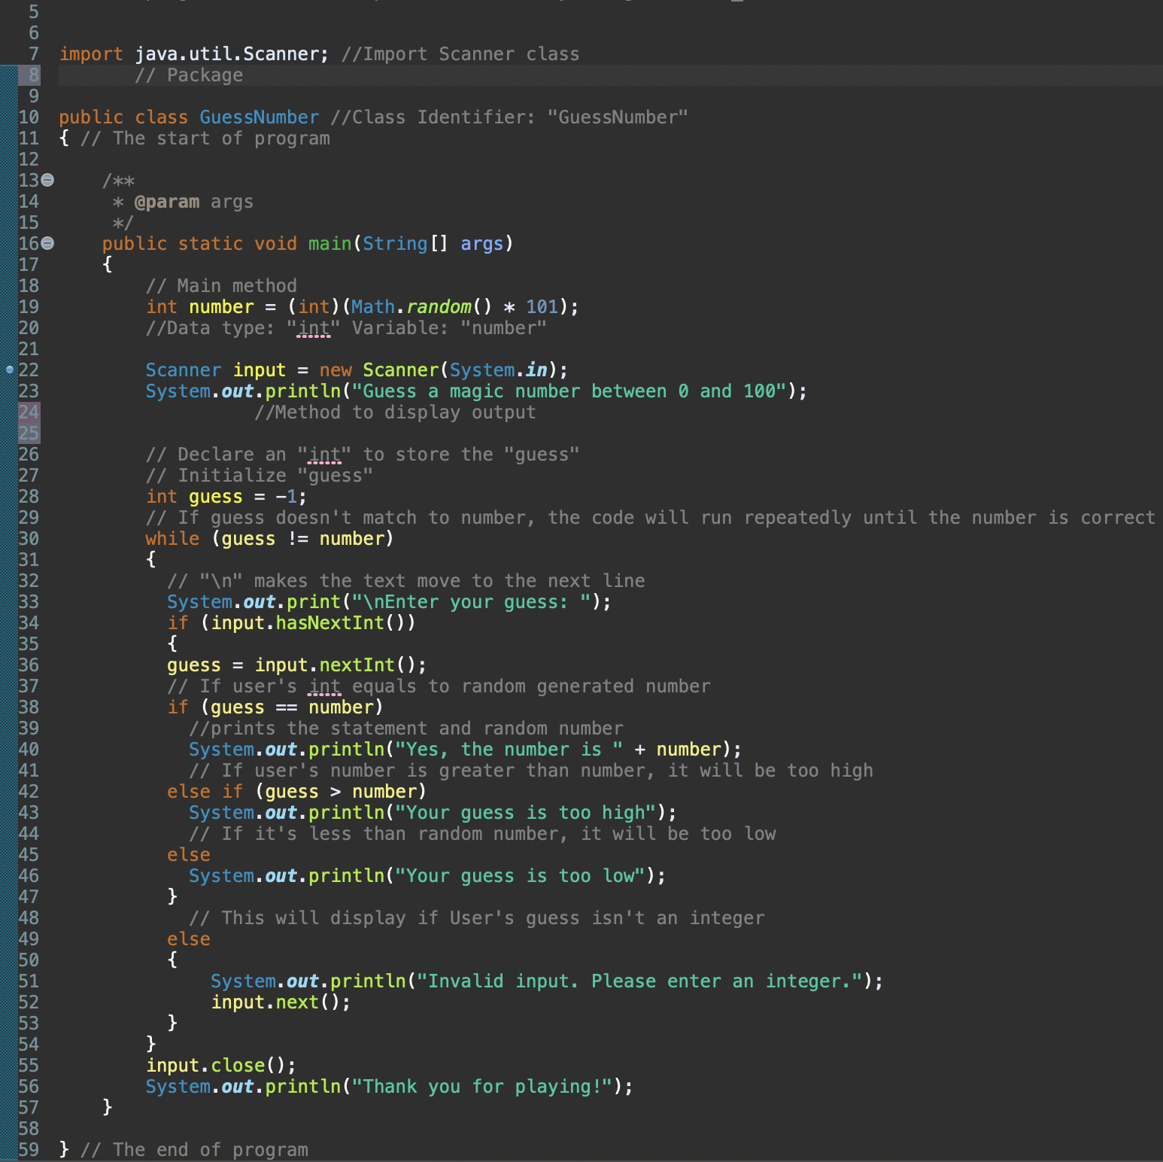

ANY OTHER TOPIC?

Module 2
[ADD Headings 2 for the different topics then add your documentation from the lectures]

Module 3
[ADD Headings 2 for the different topics then add your documentation from the lectures]

Module 4
[ADD Headings 2 for the different topics then add your documentation from the lectures]

Module 5
[ADD Headings 2 for the different topics then add your documentation from the lectures]

